PROJECT REPORT
CINEMA PRO
Created By :
Karansinh Parmar
BCA - 6
Under The Guidance Of :
PROF. KISHORSINH VALA

Submitted To :
GEETANAJALI GROUP OF COLLEGES


Affiliated To :
SAURASTRA UNIVERSITY
For Academic Year
2025-26


Acknowledgement

I am pleased to acknowledge that my project has been successfully completed. This achievement would not have been possible without the valuable guidance, encouragement, and support of my teachers. I would like to express my sincere gratitude to all my teachers for their constant motivation and assistance throughout the completion of this project. Their insights and constructive feedback have been a great source of learning and inspiration for me.

I am especially thankful to Prof. Kishorsinh Vala for their dedicated guidance, continuous support, and valuable suggestions, which helped me overcome challenges and complete this work successfully. I also wish to extend my thanks to my classmates, friends, and family members for their encouragement and cooperation during this project. Their belief in my abilities gave me the confidence to work hard and complete this assignment with sincerity and dedication.



PERTICULARS | 
Introduction:  - Abstract  - Purpose | 1
Project Profile | 2
SDLC process model | 3
Software Ressources | 5
List of Modules | 5
Data Dictionary | 6
DFD | 10
Level 0 Diagram | 11
Level 1 Diagram | 11
Testing-Testcases | 12
Screensort | 13
Limitations | 20
Future Enhancement | 20
Webliography | 20

Abstract
The main objective of this project is to manage information related to the Cinema Pro, including customer details, menu items, and daily orders. It also handles important activities such as online/offline payments. Users can update their account details and change their security password for safe access. The Admin has the authority to add new users, manage staff, update the menu, and monitor overall restaurant activities for efficient operations.

Purpose
To reduce the headache of maintaining manual records of restaurant activities such as orders, payments, and menu updates.Searching customer details, bills, or menu items will become more efficient and faster compared to manual searching.It will also provide assurance that each staff member’s attendance and daily work performance are recorded timely.Overall, it will reduce the cost and time of the restaurant management in handling operations, improving accuracy and efficiency.

Profile:

Project Title : Cinema Pro

Developpement Software : Visual Studio(Vs Code)

Front End Tool : Html, Css, JavaScript, Bootstrap, Json

Back End Tool: php, Mysql
Academic Year : 2025-26

Developed By : Karansinh Parmar

Submitted To : Geetanjali College



The Process Model used in our projects "Cinema Pro" is waterfall model.

- The Waterfall Model:

The waterfall model is a sequential design process, used in software development The Process Model used in our projects "College Management System" is waterfall model.processes, in which progress is seen as flowing steadily downwards (like a waterfall) through the phases of Conception, Initiation, Analysis, Design, Construction, Testing, Production/Implementation and Maintenance.

The waterfall development model originates in the manufacturing and construction industries: highly structured physical environments in which after-the-fact changes are prohibitively costly, if not impossible. Since no formal software development methodologies existed at the time, this hardware-oriented model was simply adapted for software development.

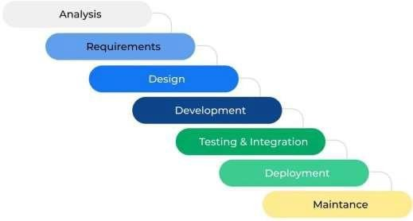

Reason the waterfall model in the software development cycle:

-> Since we have well known,clean and fixed requirements therefore it best suits for software development.
-> Out product defination are stable.
-> technology is clearly understood.
-> the project is short.

Advantages of the waterfall model:
-> this model is simple and easy to understand and use.In,this model phases are processed and completed one at a time and phase do to overlap.
-> waterfall model works well for smaller project where sequence is very well understood.



Frontend desing tool : Microsoft Visual Studio
Backend Design Tool : Mysql Server

Code-Behind Langauge: Php

  - Functionality:
    - Login/Logout
    - Register
    - Ticket Book
    - Admin handling
    - Add/remove movies





    - Home
    - Movie
    - Tariler
    - About
    - Sign in

Data Dictinory

Admin

FIELD | DATA TYPE | CONSTRAINTS
Id | int | Primary Key (A.I.)
username | Varchar(500) | -
password | Varchar(255) | -

FIELD | DATA TYPE | CONSTRAINTS
bookingID | int | Primary Key (A.I.)
movieID | int | -
bookingTheatre | Varchar(100) | -
bookingType | varchar(100) | -
bookingDate | varchar(50) | -
bookingTime | varchar(50) | -
bookingFName | varchar(100) | -
bookingLName | varchar(100) | -
bookingPNumbeR | varchar(12) | -
bookingEmail | varchar(255) | -
amount | varchar(255) | -
ORDERID | varchar(255) | -
DATE-TIME | datetime | -
bookingtable
feedbacktable

FIELD | DATA TYPE | CONSTRAINTS
msgID | int | Primary Key (A.I.)
senderfName | varchar(50) | -
senderlName | varchar(50) | -
sendereMail | varchar(100) | -
senderfeedback | varchar(500) | -
FIELD | DATA TYPE | CONSTRAINTS
movieID | Int | Primary Key(A.I)
movieImg | varchar(150) | -
movieTitle | varchar(100) | -
movieGenre | varchar(50) | -
movieDuration | int | -
movieRelDate | date | -
movieDirector | varchar(50) | -
movieActors | varchar(150) | -
mainhall | int | -
viphall | int | -
privatehall | int | -
movietable
user

FIELD | DATA TYPE | CONSTRAINTS
id | int | Primary Key(A.I)
name | varchar(100) | -
password | varchar(100) | -
lastname | varchar(100) | -
number | varchar(15) | -
email | varchar(100) | -



- Data flow daigram symbol :

Symbol | description
 | Data flow- data flow are pipelines though the packets of information
 | Process:A process or task performed by the system.
 | Entity: Entity are object of the system.A source or destination data of a system.
 | Data Store:A place where data to be stored.

- 0 level dfd(context daigram):

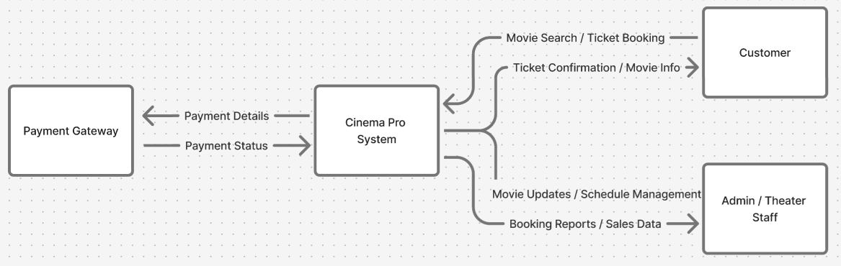

- Level 1 DFD :

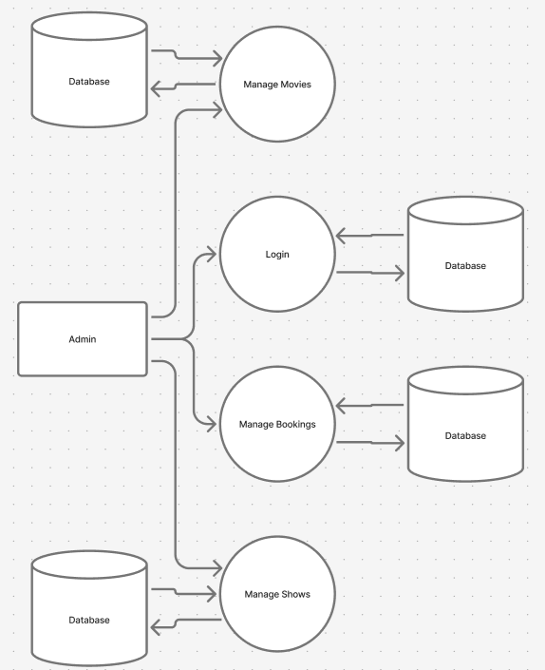


A test case for a website is a detailed set of steps used to check whether different features of the site work correctly and provide the expected results. It helps verify that all web pages, forms, links, and functions operate as intended. For example, testers create test cases to check login forms, navigation menus, or contact forms. These test cases ensure that the website is user-friendly, secure, and free from errors before it goes live. Proper testing improves the website’s quality, performance, and overall user experience.

 | Description Actual  Login with valid credentials |  | Test Steps  1. Go to login page 2. Enter valid username & password 3.  Click Login |  | Input Data  Username: adminPassword: 123 |  | Expected Result  Redirect to dashboard |  | Result  Redirected successfully
 | Login with invalid credentials |  | Enter wrong password |  | Username: adminPassword: wrong |  | Show“Invalid Login” message |  | Error message displayed







- Shows the website was tested properly.
- Demonstrates functionality validation for each module.
- Helps future developers and testers understand testing scope.


Screen sorts:
Home page screen :
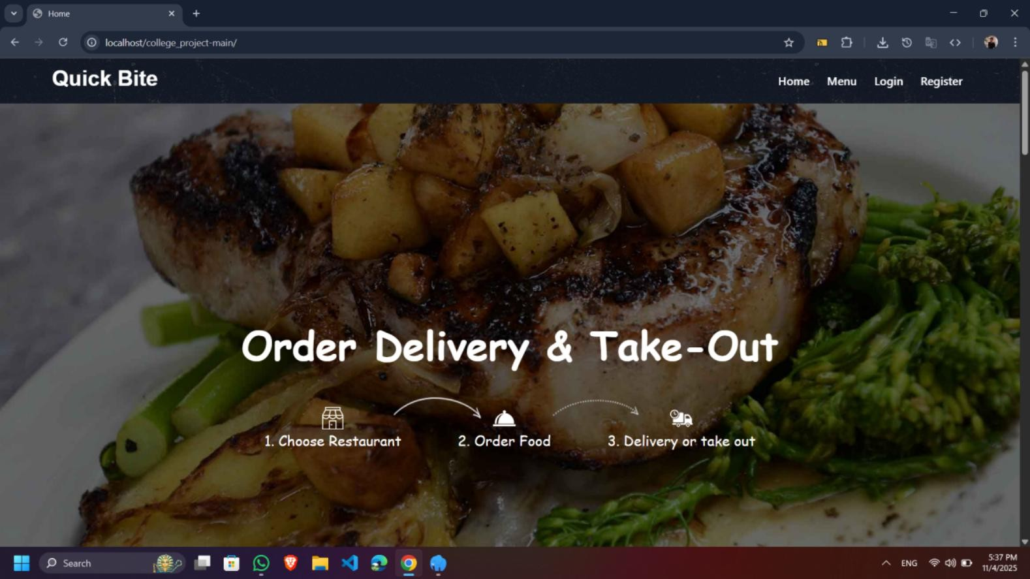
→ In this section of page user get all options & access functionality of it.
→ To close the site user can use either close button or close browser.
→ To Click on logo user will get back on This page.

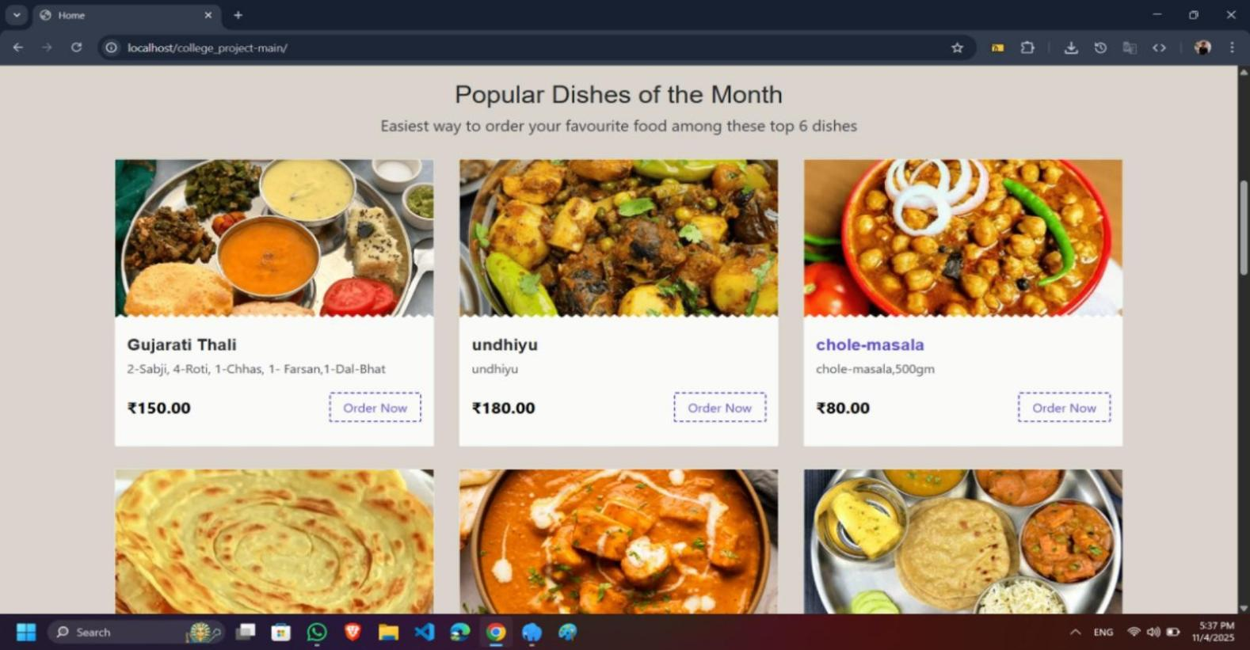

- Log in Page :
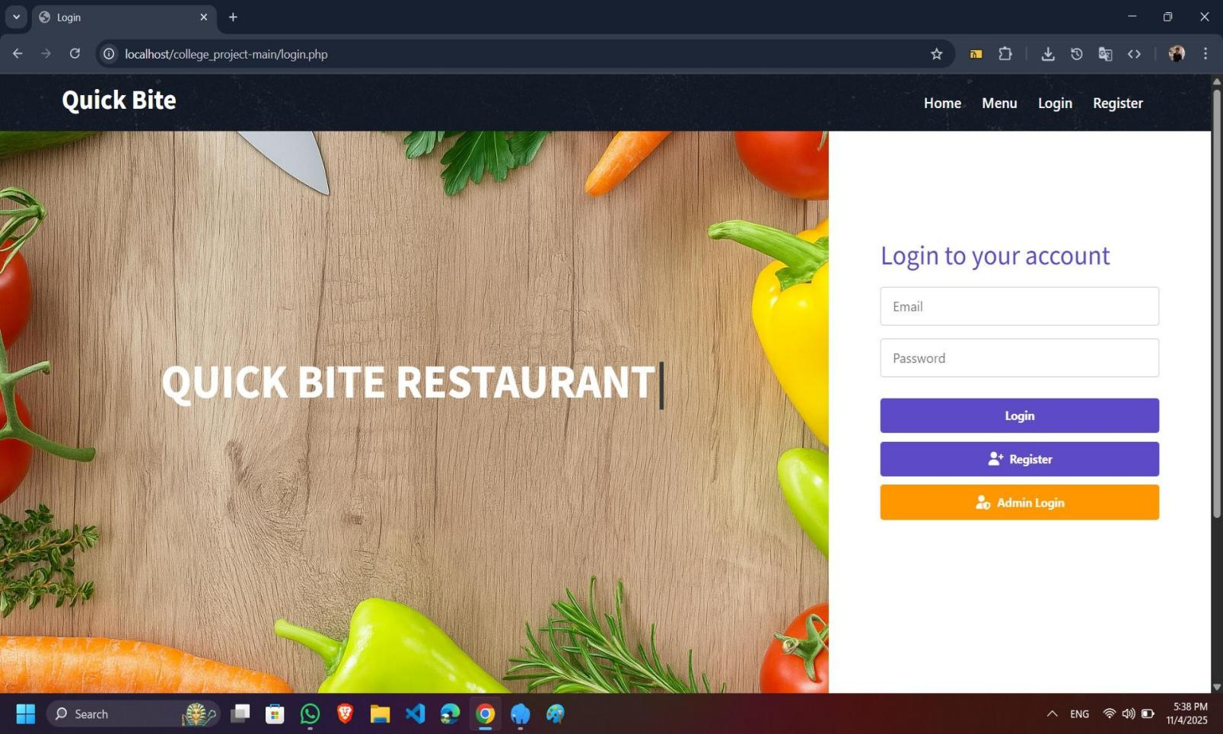
→ In this page user must give username & password.
→ If the password is correct, then he will be redirect to home page else he gets the prompt.
→ If the user forgot the password, then he will be able to contact with admin for reset password.
- Register Page :
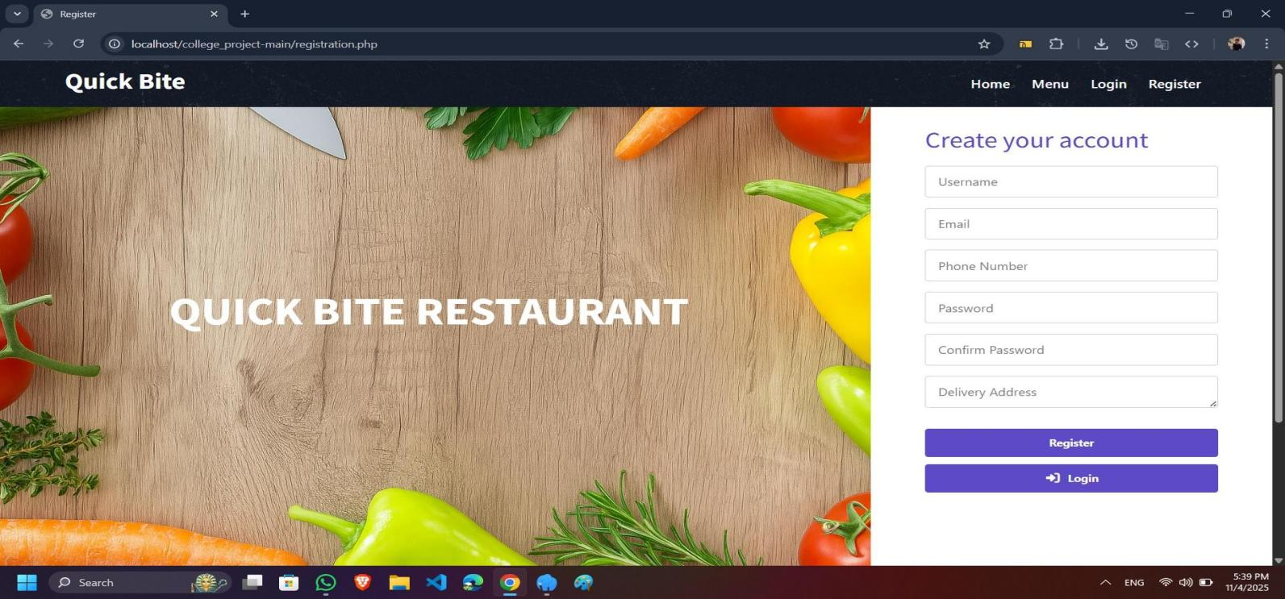

- All Menu :
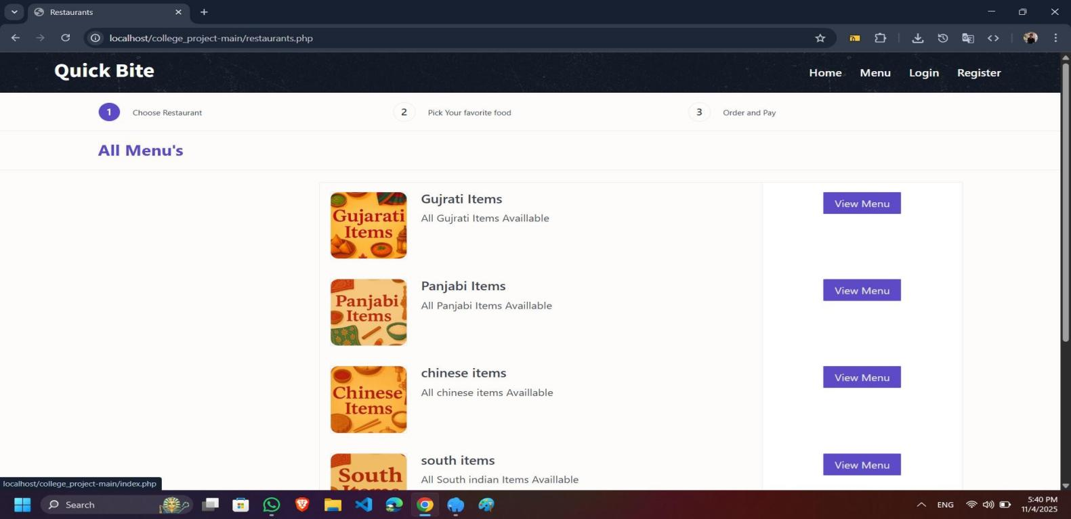

→ All the menus are shown on this page from which the user can choose the menu according to his/her own taste.
→ From this page, the user can add their chosen menu to the
cart.
- Add To Cart :
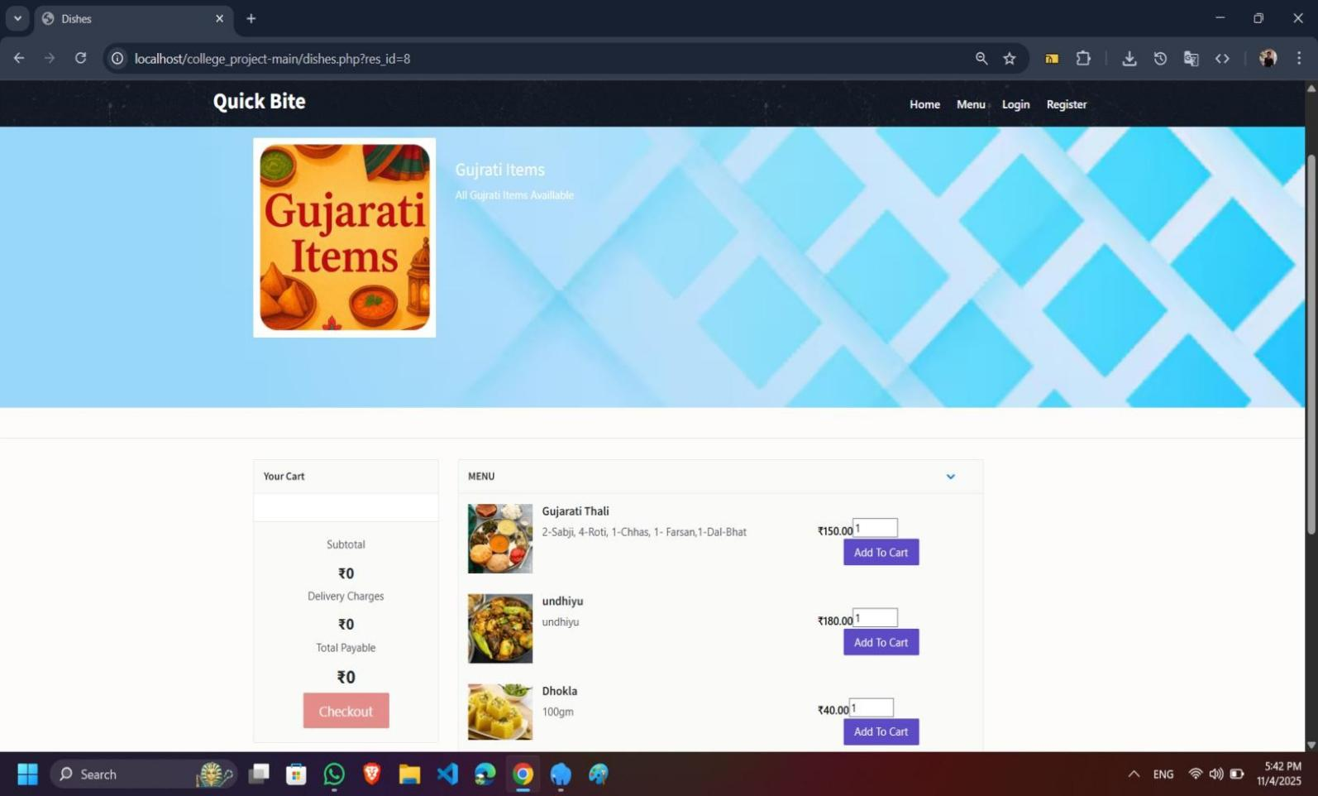

- Contact_us

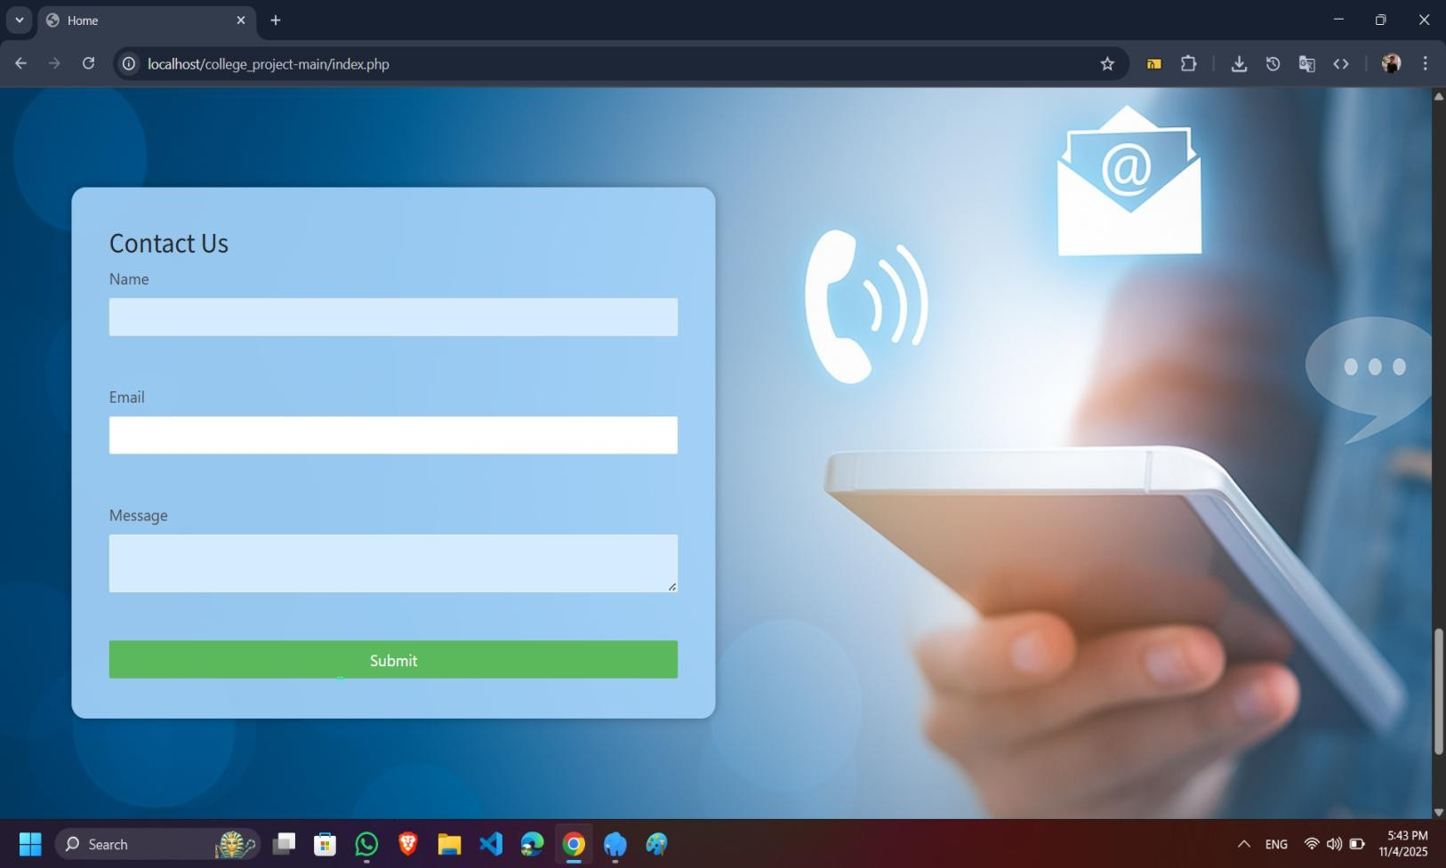
→ On this page, users contact the admin to get their queries resolved.

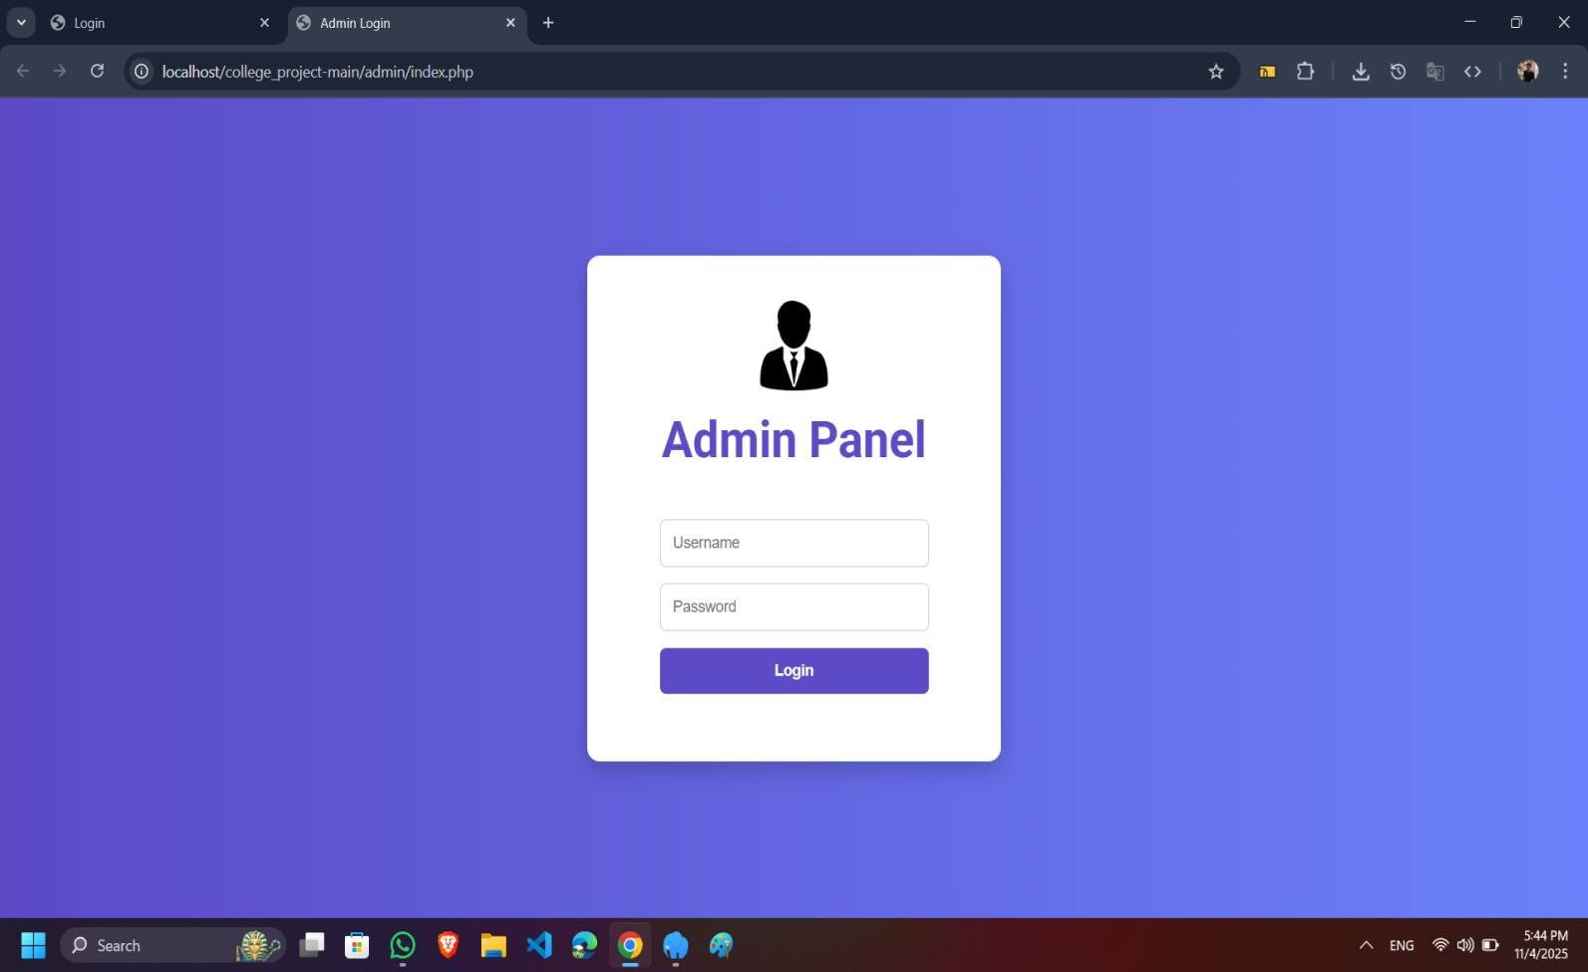
Admin Page:
→ After logging in to this page, the admin can handle all orders or items.

Admin Dashbord :
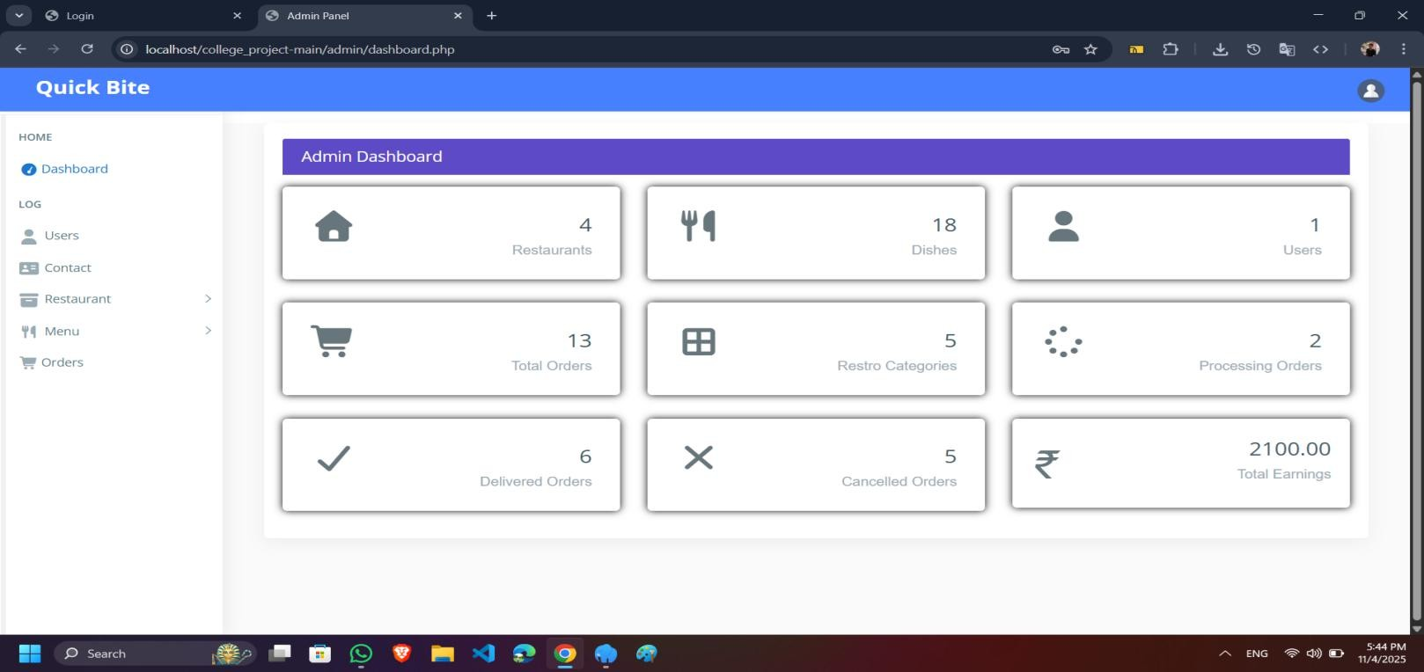
→ In this page admin can see all the dishes, user, total order, res categories, processing order, delivered order, cancelled order, total earnings.

All Users Details:
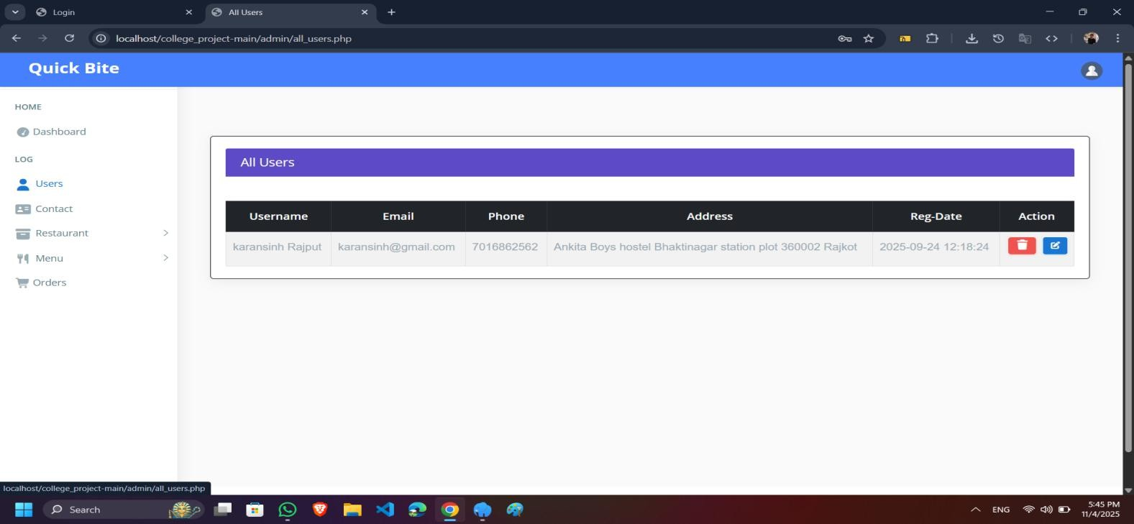
→ In this page admin can seen all the users.
Admin can change the user name, password, email,phone,address and delete

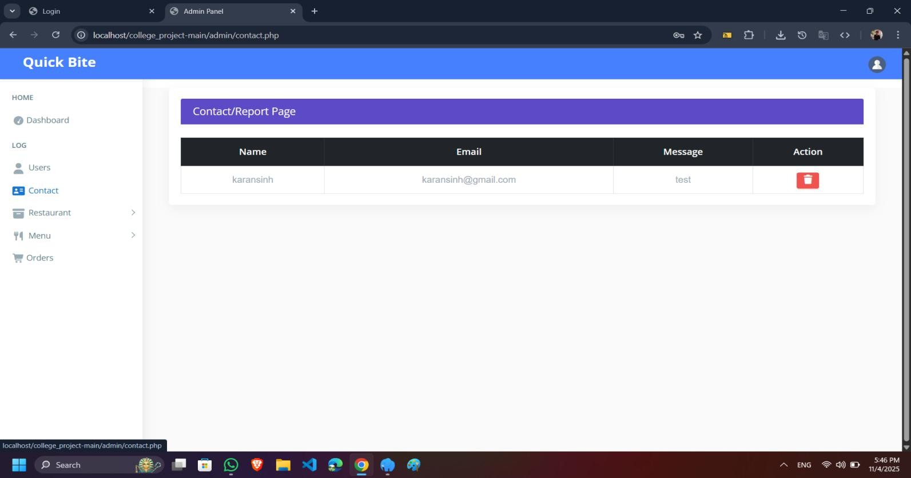
All contact :
→ In this page admin can seen all the report submited by the user and admin take action.

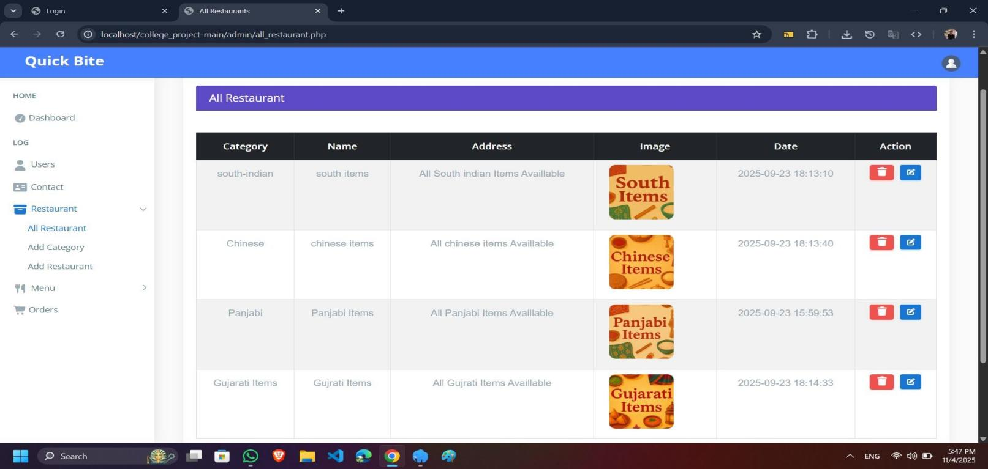
All Item’s
→ In this page admin can seen all items and add the new items or add new category.

All menu :
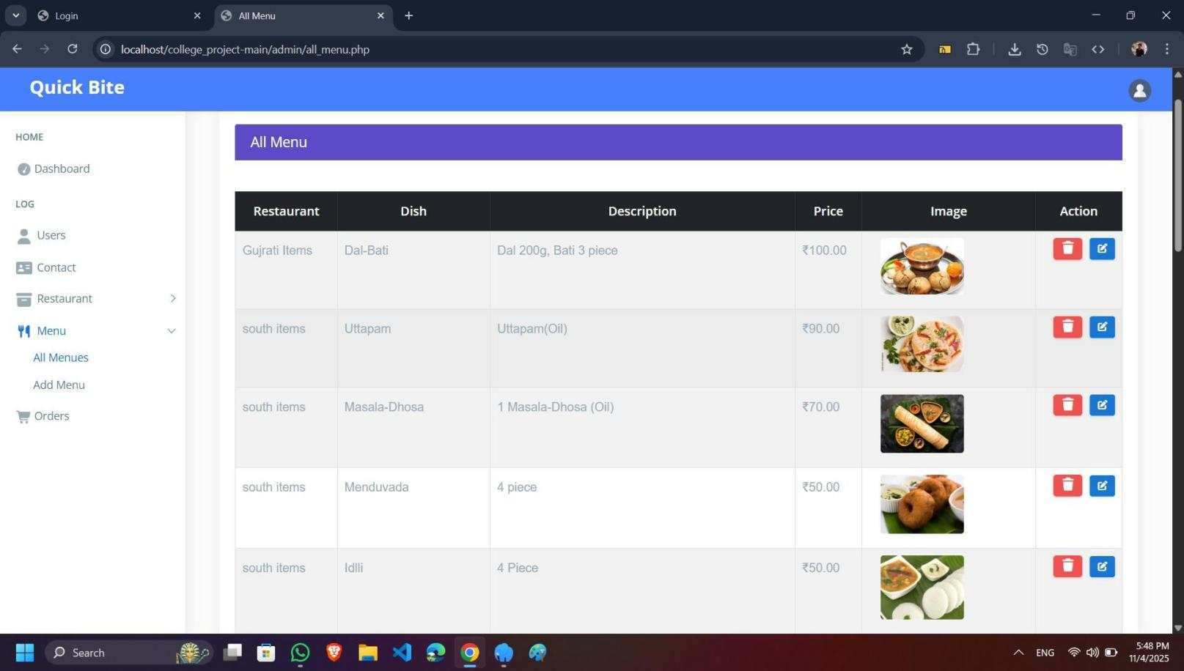
→ In this page admin can seen all menu’s and add the new menu.

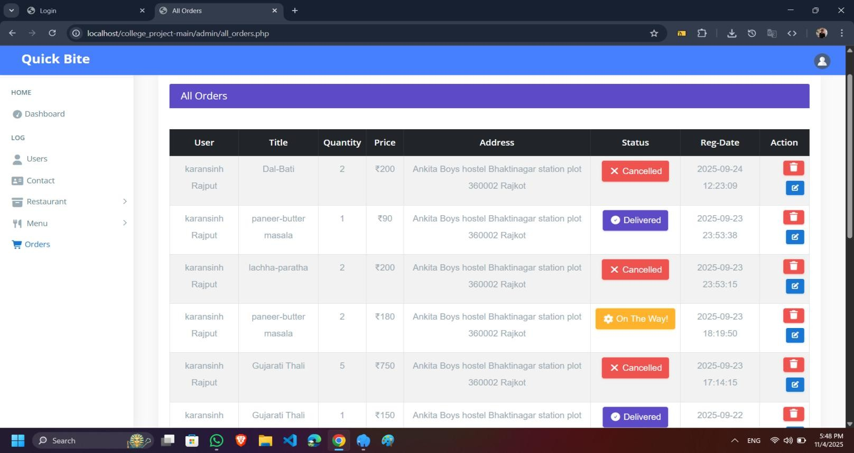
Order’s
→ In this page admin can seen all order’s details.

  - Lack of Real-Time Collaboration.
  - Limited Security Features
.

- Integration of a Cloud-Based Database.
- Enhanced Reporting and Analytics.
- Integration with Payment Gateways.
- Improved User Interface Design.

Webliography

https://www.php.net/docs.php https://dev.mysql.com/doc/

